You are given the root of a binary tree.

A ZigZag path for a binary tree is defined as follow:

* Choose **any** node in the binary tree and a direction (right or left).
* If the current direction is right, move to the right child of the current node; otherwise, move to the left child.
* Change the direction from right to left or from left to right.
* Repeat the second and third steps until you can't move in the tree.

Zigzag length is defined as the number of nodes visited - 1. (A single node has a length of 0).

Return *the longest* ***ZigZag*** *path contained in that tree*.

**Example 1:**

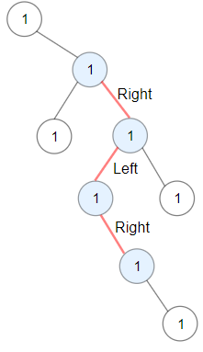

Input: root = [1,null,1,1,1,null,null,1,1,null,1,null,null,null,1]  
Output: 3  
Explanation: Longest ZigZag path in blue nodes (right -> left -> right).

**Example 2:**

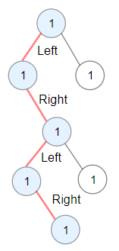

Input: root = [1,1,1,null,1,null,null,1,1,null,1]  
Output: 4  
Explanation: Longest ZigZag path in blue nodes (left -> right -> left -> right).

**Example 3:**

Input: root = [1]  
Output: 0

**Constraints:**

* The number of nodes in the tree is in the range [1, 5 * 104].
* 1 <= Node.val <= 100